August 2024

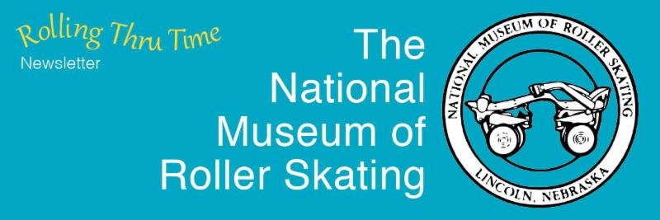

Visit our Website

Museum Aquires Usher's Skates

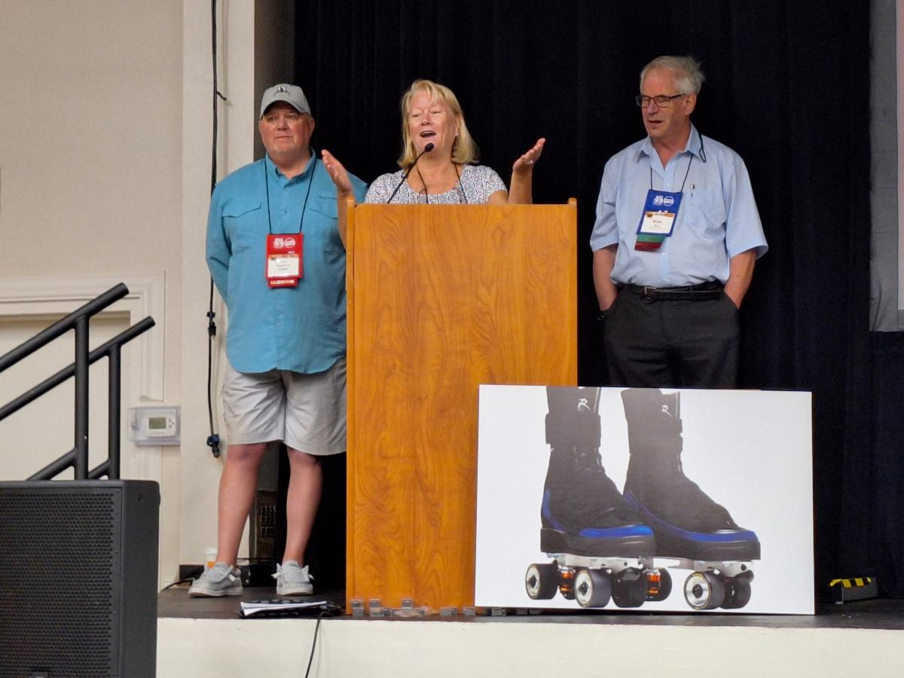

Pictured Left to Right: Scott Riegelman, Kris Wall Friesner, and Kim Wall.

Kris is speaking at the Roller Skating Association’s annual convention last May in Las Vegas. She is talking about the Museum’s recently acquired signed copy of the skates R&B artist Usher used in this year’s Super Bowl.

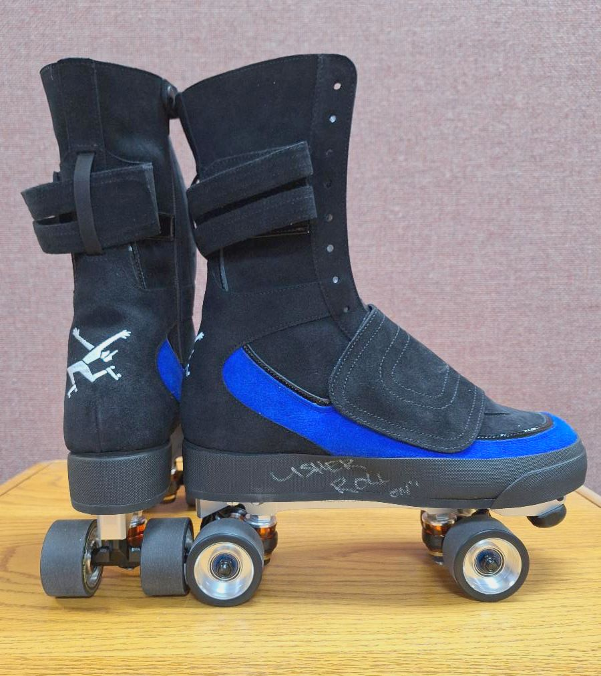 | 
By Alan Bacon

﻿The Museum has a new artifact, perhaps the most popular in the Museum today: A signed copy of the roller skates R & B artist Usher used during the halftime show of Super Bowl LVIII in Las Vegas, Nevada, this year. It came about in part because of one of the prominent families in roller skating, the Wall family. “Having been in the skating industry for my entire life,” said Kris Wall Friesner, CEO of Funtastic Novelties in Fort Wayne, Indiana, “it was a labor of love from the Wall
family.”

Many people had a hand in making this skate available to the Museum: Usher, Flipper's Roller Boogie, the Wall Family, and Riedell Skates. It took months of effort to be able to coordinate this process with these entities, included a couple of glitches that occurred during the process. Kris was in a unique position to be able to help coordinate communication between these groups.

Kris’s brother, Kevin Wall, who is an investor, is on the board of Flipper’s Roller Boogie. Usher has a relationship with Flippers. Kris’s other brother, Kim Wall, is president of the National Museum of Roller Skating. And she has a relationship with her “dear friends at Riedell.” She asked Riedell for a personal favor.

When Kris found out that Usher was going to be skating in the super bowl with a pair of Riedell skates, she approached her brother Kevin about getting a signed copy of those skates for the Museum. Riedell already had a relationship with Flipper’s. Kevin was excited and paid for the copy. The retail price is $1,450.

Of course, this all depended on the cooperation of Usher, who Kris said was very excited about it. “I think it was his gift to roller skating,” said Kris. Usher isn’t a newcomer to roller skating. He is an experienced skater and he extensively incorporated roller skating into his recent Las Vegas residency. We never will have more people watching roller skating on national TV all over the world, than this event at the super bowl, said Kris.

“Flipper’s Quadz by Usher, handmade in the USA by Riedell Skates, were co-designed by Usher and Liberty Ross, Co-Founder and Creative Director of Flipper’s Roller Boogie Palace,” according to Riedell’s web site. “He (Usher) was very hands on. He was the final say,” said Scott Riegelman, co-owner and vice president of Riedell Skates. A team from Riedell worked with Usher’s team. Riedell had to keep the project secret. “He chose Riedell to be the manufacture of his vision of his type of Usher skate,” said Riegelman.

Riedell had worked with Usher before in producing the various skates that he used in his Las Vegas residency. Those skates were from stock boots, his super bowl skates were something new, said Riegelman. The Superbowl skates fit his theme and costumes. “It was different, but not different for us. It’s always a challenge, but it is something we do here on a custom basis,” said Riegelman. Riedell had also worked with Flippers with their rinks in Europe and Rockefeller center.

Flipper’s World “is a community united through skate-inspired apparel, immersive experiences, parties, partnerships, and a collective joy for roller skating,” according to the website www.flippers.world. The inspiration for this company dates back to the late 1970s, during the height of the roller disco era, to a rink in Los Angeles. “From 1979 to 1981, Flipper’s Roller Boogie Palace was the place to be yourself, find yourself and express yourself,” states Liberty Ross on the website, who’s father co-founded the rink. “My dad believed roller skating could save the world.”

Besides being able to purchase the Quadz skate on the website, the book “Flippers Roller Boogie Palace 1979-1981" can also be purchased. Another tab on the website links to their London rink, “one of the premier roller rinks in the world” according to Riedell. They were also involved with the summer rink at the Rockefeller Center in New York.

Usher’s skate is already on display at the Museum, and a loud WOW can be heard as patrons discover it.

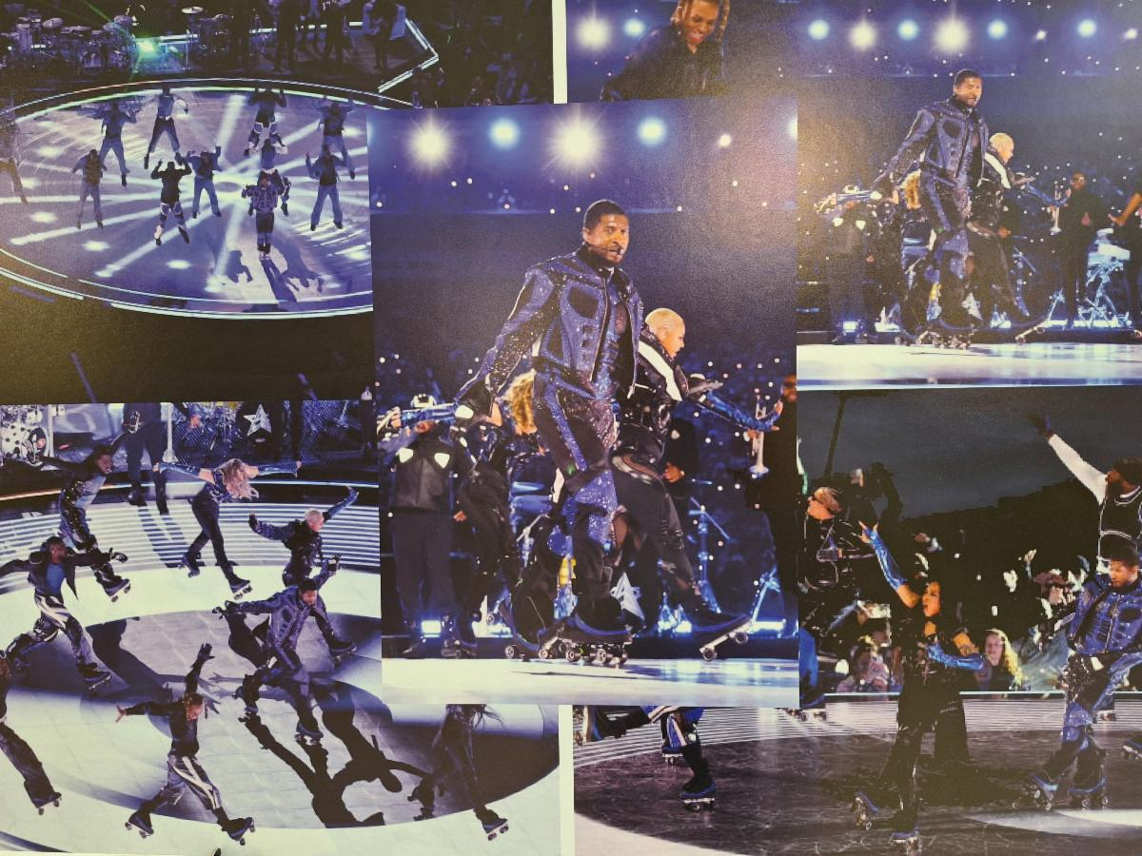

Usher at Super Bowl LVIII in 2024.



Welcome Skating Community

The Museum newsletter will now not be limited to Museum members only. This action was passed during a board meeting July. It was felt that a much larger segment of the skating community would benefit from this action. One goal of the Museum is to educate as many people as possible to the rich history of roller skating. This action helps with this goal. Though there won’t be any additional expense to this action because the newsletter is sent electronically, your support would be appreciated.

If making a donation of $35 or more, why not become a member. Besides a discount at the Museum store, most importantly, by showing your support in this way, a larger Museum membership can be of benefit when the Museum applies for grants, which has brought great benefits to the Museum. Either way, your support is essential and greatly appreciated.

If you are not sure if your membership has expired, click the "List of Current Members" button below.

Any questions email museumstaff@usarollersports.org

Donation or Membership

List of Current Members

﻿USA Roller Sports Nationals
Brings 1000 Competitors,
Coaches & Families to the Museum

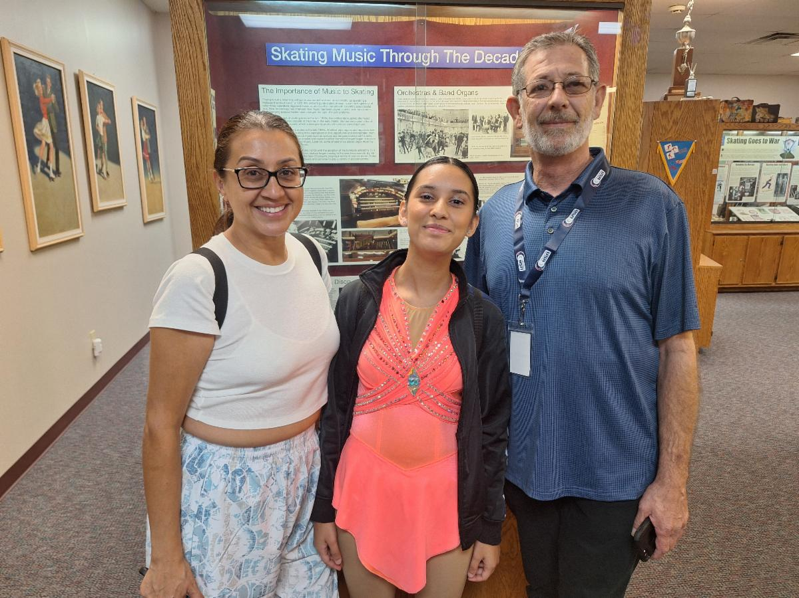

Pictured Above: Jeff Biggs (right) is a coach for Dominic Cangelosi, owner of Moonlight Rollerway in Glendale, Calif. He is one of many who visited the Museum with great skating stories. He tried out for the disco skating movie, Roller Disco, in 1979. At the same time, he was working at Sherman Square Rink in southern Calif. where Cher rented the rink on Monday nights for her friends.

Pictured to his left is his student, Elora Padilla, and to the far left is her mother Mariela Krause.

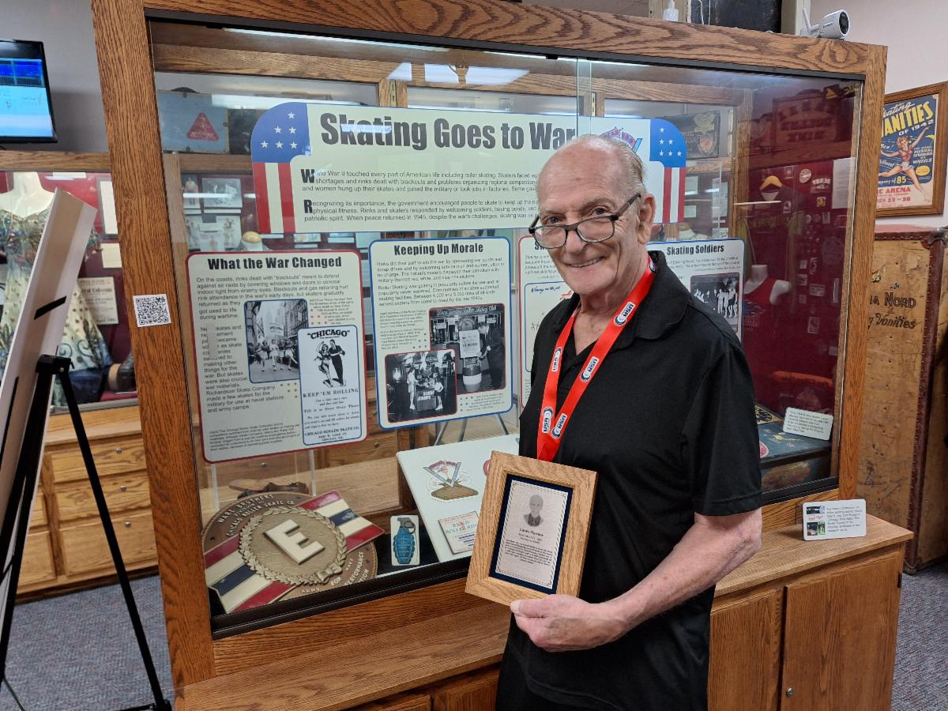

Pictured Above: James Harmer has been coaching for 62 years. He replaced George Pickard at the Rollercade rink in Clevland, Ohio, in 1963 when Pickard went to work for the RSROA.

﻿Harmer was a competitive skater from 1953-1963. He placed 15 times in 5 different events. Once he taught 200 girl scouts at one time. He is holding his Hall of Fame plaque.

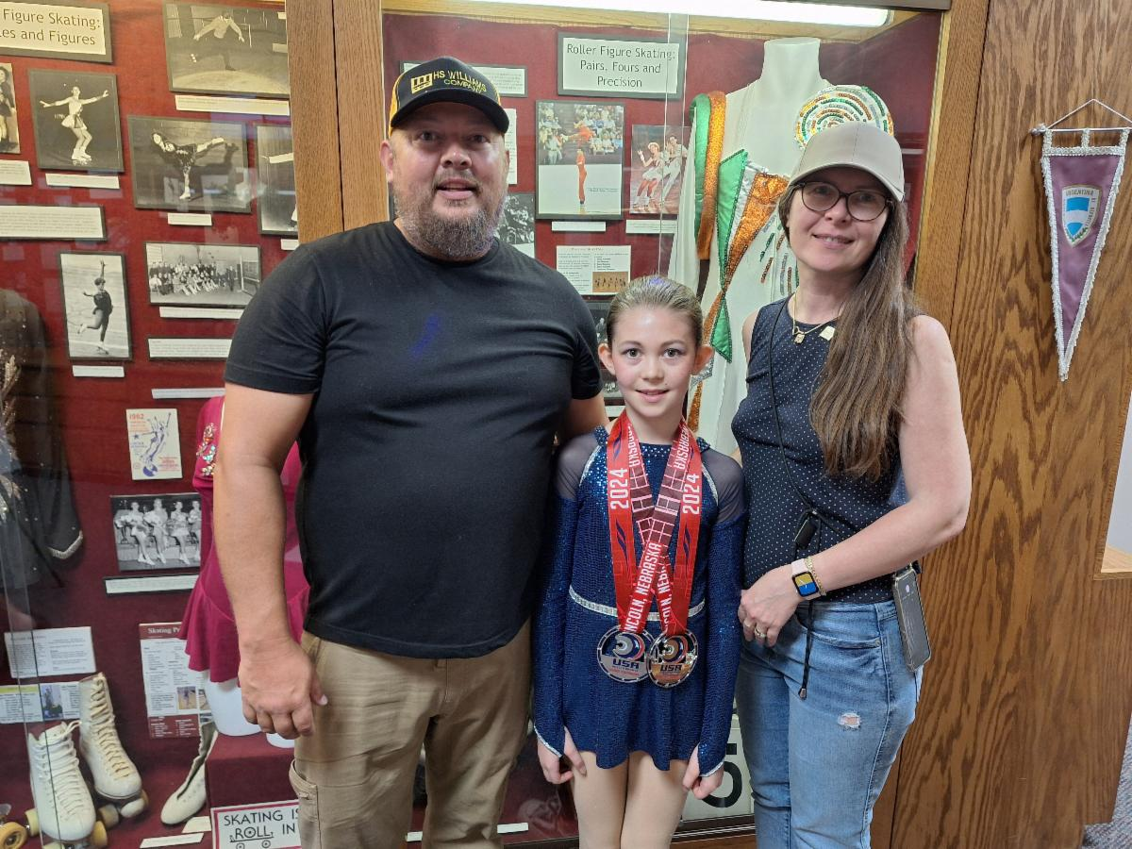

Pictured Above: The Porter family,
Pictured Below: The Samantha family.

These are two examples of the many families of competitive skaters visiting the Museum during Nationals.

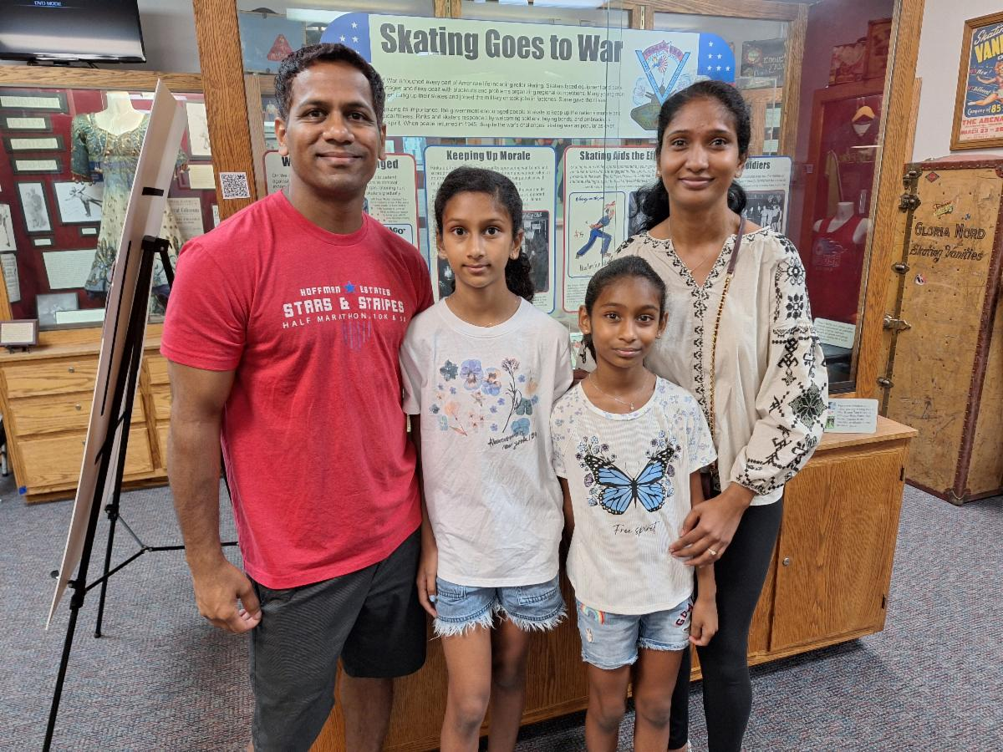

RSA Convention Helpers

Pictured below on the right is Linda Miner, Museum trustee at the RSA convention in May in Las Vegas, Nevada. She ran the Museum booth.

The second picture is Charlene Conway (right), Museum trustee, selling raffle tickets during the President’s Dinner to Doug Warren (left). She along with other Museum trustees, RSA board members and others, helped make the raffle a success by selling raffle tickets. The RSA helped by providing a booth for the Museum, and facilitating the selling of those tickets.

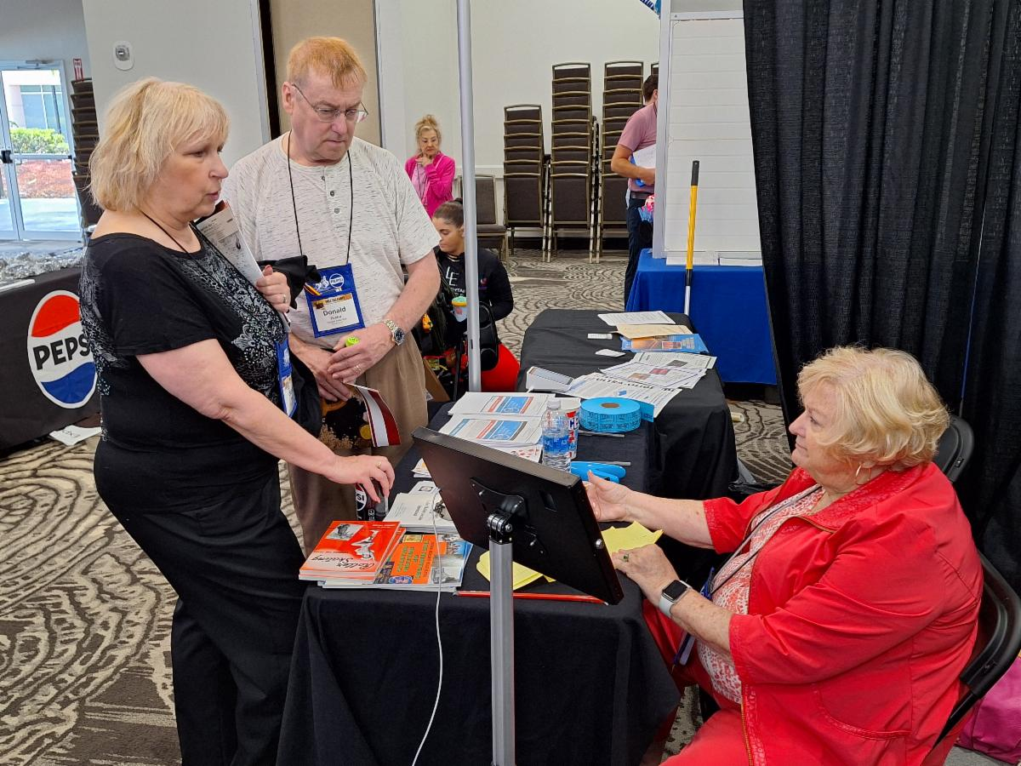

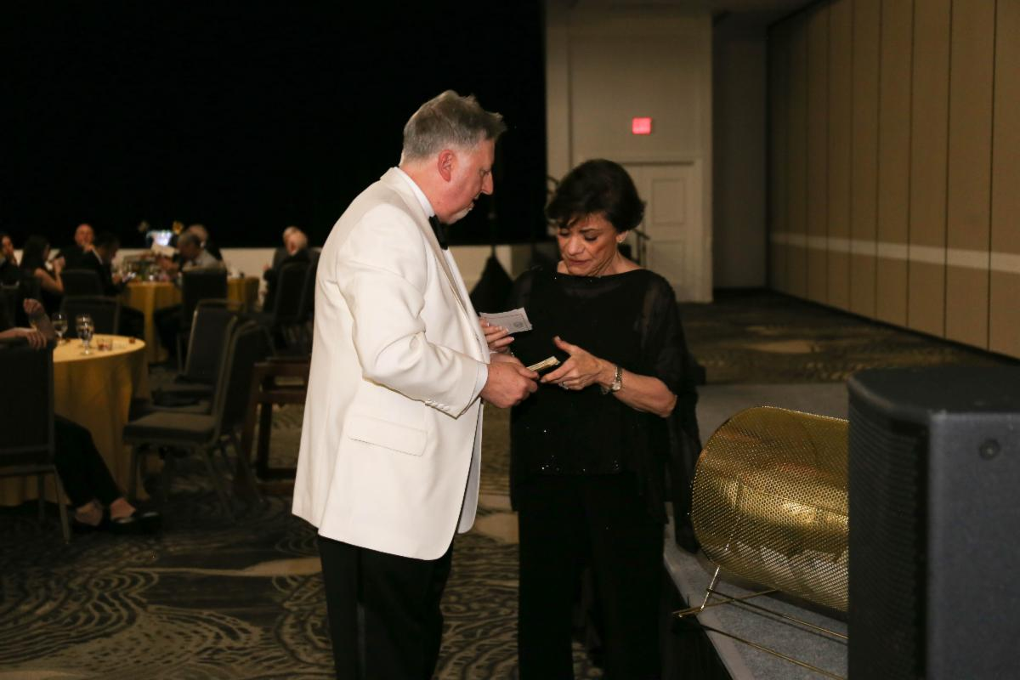

Message from Frank Torries, Museum Golf Coordinator
I want to thank all the fellow rink operators, RSM members, and friends that participated in our golf outing this year in Orlando. We are in our 2nd year of hosting this outing as a fun event to benefit the museum. We had a great turnout with 24 golfers. We realize that everyone could just go play golf but we greatly appreciate the support we get to make this a small but beneficial fundraising event for the museum. The fellowship, camaraderie, and harassing each other on the course are the things that makes this golf outing fun. We get sponsors who are excited about donating dollars to the museum for the golf outing and we thank them all profoundly. So, Las Vegas here we come as we prepare for golf next year in the desert.

Ralph Dunham – I’m coming for you!!!

Huge thanks to this years’ sponsors:
REBECCAS – ROLL ON FLOOR COATING
STAR WHOLESALE LIGHTING AND SOUND
JBL WORLD INSURANCE
SURE GRIP SKATES
GOLDEN HORSE RENTALS
RIEDELL SKATES.

We will gladly accept any other venders that would like to support our event next year.

In closing, I just want to say that most of you who participated know my love of the game and putting this golf event together is a pleasure. I look forward to seeing you all next year. Thanks again for your support.

-Frank Torries
Museum golf coordinator

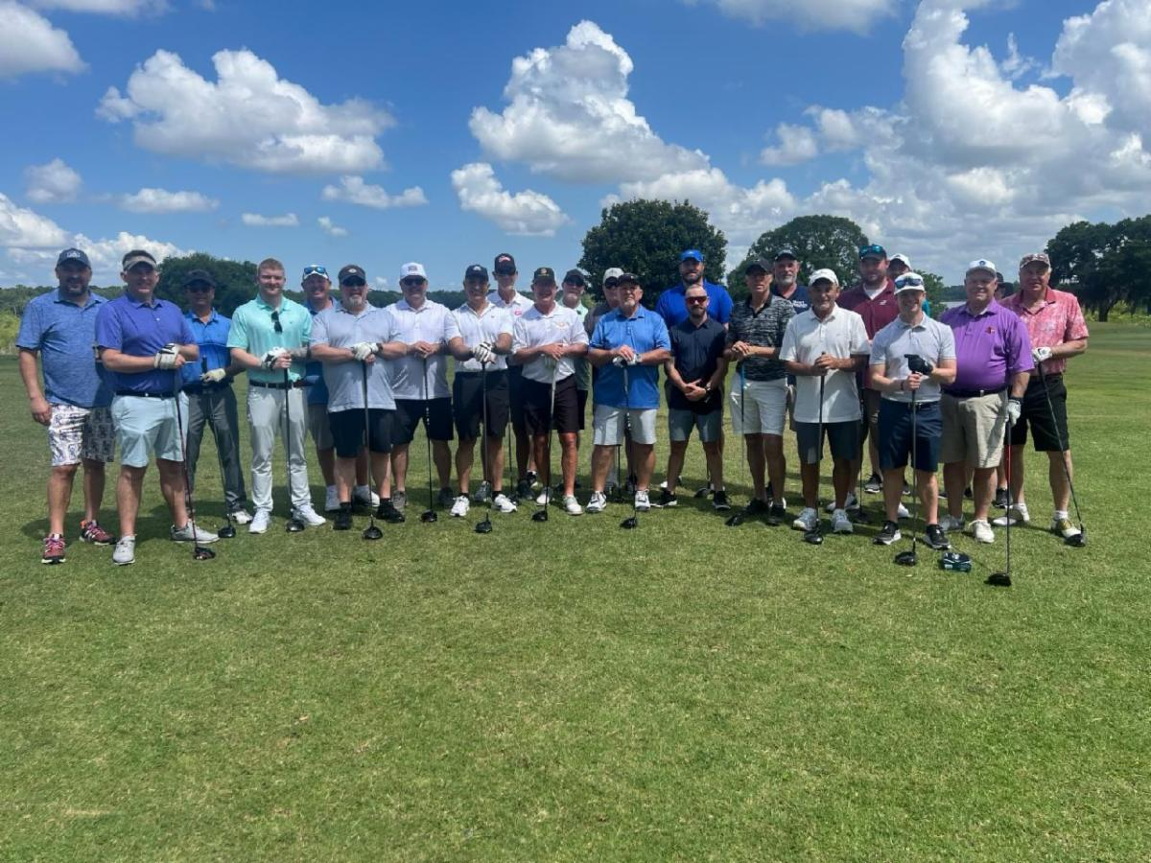

Fundraisers and Donations

Raffle
The annual raffle, the biggest fundraiser of the year for the Museum, took place at the RSA national convention in Las Vegas, Nevada in May.

1st Place Verna Quaranto
2nd Place Connie Wahlig
3rd Place RSA Section 5

Tickets sold were 269 for net proceeds of $6,725.
Besides Museum trustees, thanks go to the many RSA board of directors who sold tickets, along with Megan Braun.
Cort Wahlig and Lina Miner were the largest sellers.

Lincoln Day Fundraiser
The follow gave during the month of May to the annual Lincoln Day Foundation fundraiser in behalf of the Museum. Each dollar of donation is supplemented by the Foundation based on the amount of financial support each organization receives from its supporters.

Zoe Tien, Mary Boschult, Nellie Anderson Lillie, Cathy Frances, Dennis Pickard, Max McKillip, Peggy Young, Alexis Cruz, Kenneth Edwards, Kim Wall, Shelly Smith Hornback, Richard Cabral, Annelle Anderson, Betty Ann Danna, Caroline Mirelli, Seven Blond, and Section 5.
Dianne & Megan Braun Donation in memory of Chase Moore, son of
Shawn and Lisa Moore of Pearwood skate.
James Vannurden “Always thankful for this place starting my
museum career.”

Donations thru the RSA
The following people donated to the Museum thru the RSA. The RSA has a box on their renewal form that allows members to make donations to the Museum.
Marsha Leary, Gail Rushing, Barbara Dowd, Janis Gallucci, Lenore Remley, Nancy Phillips, James Turner, William Griffis, Roberta Jackson, Ruth Ross, Tammy Cooney, Christi Warren, Scott Sackin, Sally Melle, Joni Zornes, Rolladium, Sparkles Smyran, Sparkles Gwinnet, Richard Manns, Ralph Marinelli, Charlene Conway, Linda Lester, Roger Wampack, Dona Ely, Tamara Kendrick, Robert Labriola, Steven Forstner, and Terry Anselmi.
Also, the RSA itself, gives an annual donation to the Museum

Special Thanks
The following people need to be recognized for their recent generous donations.
Jim Ball, owner of Sure-Grip Skate Company
Verna Quaranto, Owner of The Rollercade in San Antonio, Texas
Wendy Browne, photographer for the RSA national convention

Lowe’s Portable Tent Rinks:
A Bygone Era

By Alan Bacon

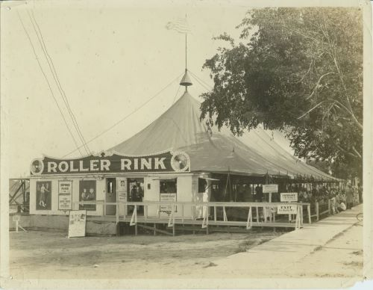

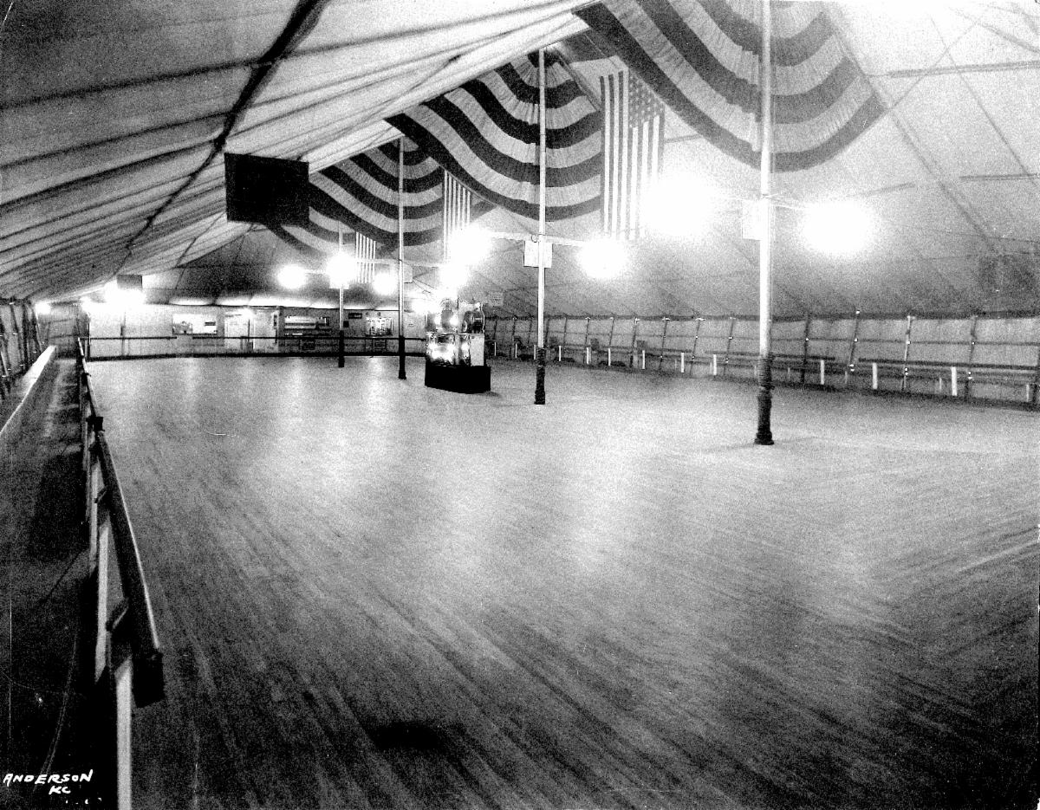

Roller skating has gone through many eras. One of most colorful was the time of portable tent rinks that were prominent, especially in rural areas, in the first half of the 1900s. Both the Chicago and the Richardson skate companies, the two most important vendors of skates and rink supplies in this era, sold them.

The best proprietor of this era of tent rinks was the Lowe family. The Museum is fortunate to have an extensive collection of their photos and information, donated by the family. Their photos, along with the Fred Martin collection, are the most extensive and best-preserved photos of rinks before World War II that the Museum possesses.

In 1914, the Lowe family opened their first portable roller-skating rink in Craig, Missouri. They would go on to open similar tent rinks for the next 28 years in much of the western Midwest and Southeast, never staying over four months in one location. They survived and thrived during a thirty-year period that was the least successful time for indoor roller-skating rinks in the 20th century.

Their canvas rink had a maple floor of 60 X 120 feet that could accommodate 500 hundred skates and nearly 300 spectators. The canvas sides could be lowered in bad weather, and a stove would be lit. A Wurlitzer band organ provided the music.

It was truly a family affair. Mr. Lowe supervised the floor, Mrs. Lowe attended to the tickets, his son, C.W., managed the door, and his nephew was in charge of the skate room with 400 Richardson fiber wheels, ball-bearing skates.

Don’t be fooled in thinking that since theirs was a portable rink operation, it was less than professionally run. The genius of the Lowe’s was in the marketing and management of their facility. It rivals the best rink operations of today. There are many examples of this. In examining their photos, the professional photography company that took the photos is stamped on the back. How many rinks of this era, or even today, would go to that expense? In the photos of the vehicles below, the extent that they would go through to market their facility is obvious. Imagine these vehicles traversing the small towns as the canvas rink was being set up. It would probably rival the excitement of a circus coming to town in an era before TV and social media.

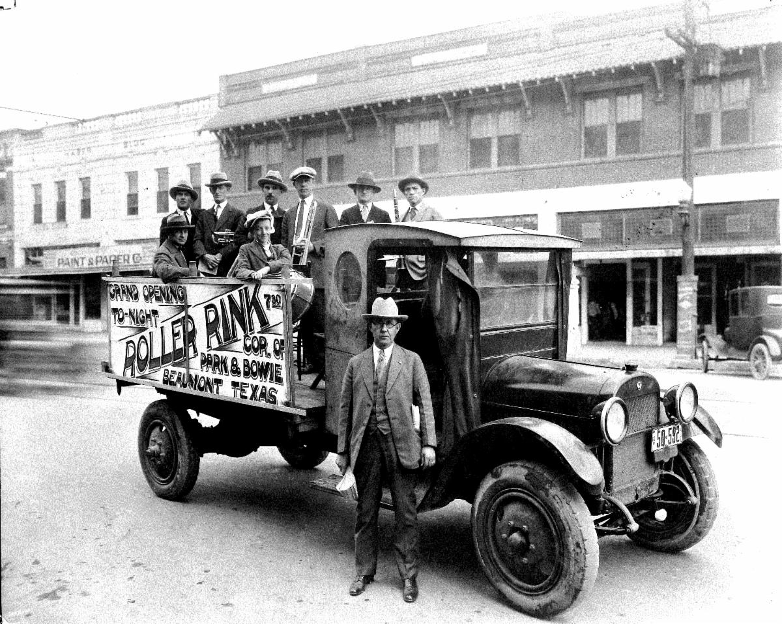

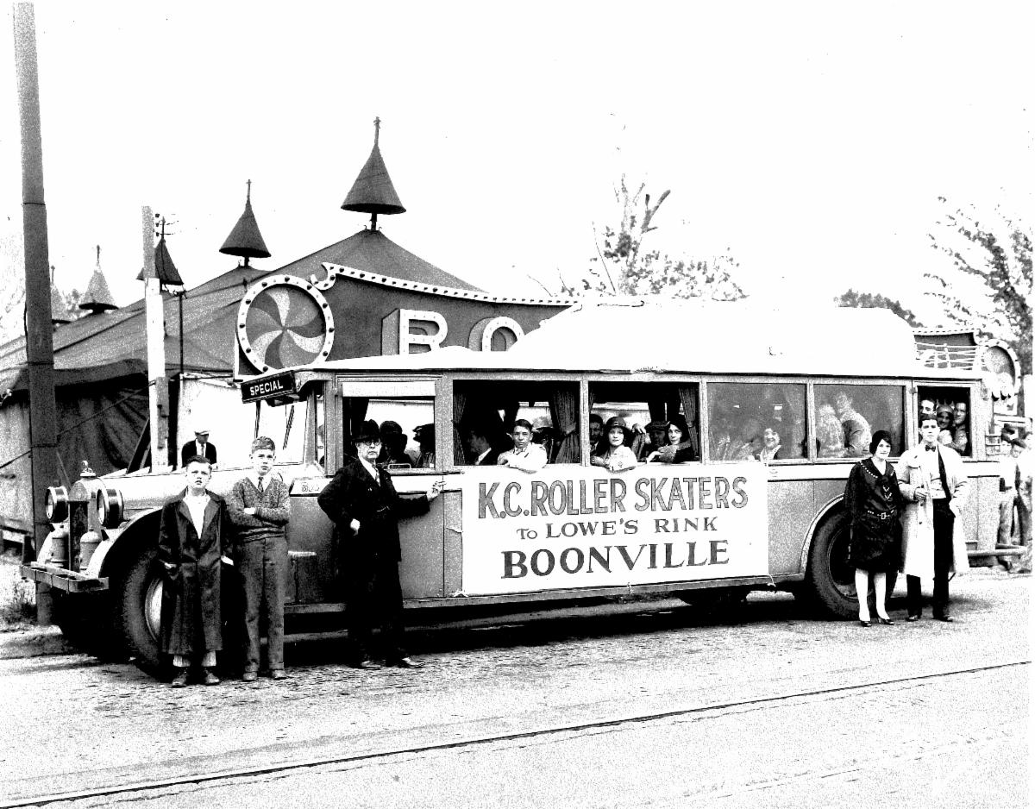

Their skills didn’t end though, at external promotion, but included what occurred after patrons arrived for skating. In an era when roller rinks didn’t always have the greatest of reputation, the Lowe’s required proper dress for the time: no denims or overalls. Proper conduct was also maintained. One patron stated that “credit is due to Mr. Lowe for his firmness in dealing with any roughness of boisterous conduct that has made the rink a place where the most refined could go with perfect safety.”

Delving deeper into their operations, a remarkable diversity of activities occurred under their tent: the Hobo Skate, the Tacky Party and the Country Jinx for example. On Saturday nights a Midnight Skate with Japanese lanterns created a Masquerade party theme when only masked skaters would be allowed to skate.

Fancy skaters were invited to perform, including famous Vaudeville skaters like Miss D’Vorak who had performed for the Queen Mary in England, or a Mr. Mac who could jump over 12 chairs.

Besides fancy performers, the Lowe’s promoted activities that would have significance to roller skating history. The Lowe’s would promote speed skating by having C.W. Lowe racing against professional speed skaters such as Roland Cioni, and William Sefferino, who both would become founders of the RSROA. In fact, Sefferino’s rink in Cincinnati, the Rollerdrome, would host the first RSROA speed meet in 1938. If traditional speed skating didn’t produce enough excitement, C.W. raced against A.H. “Monk” Robertson who was on a Harley Davidson motorcycle. The motorcyclist might have won the race, but the Lowe’s won at the ticket office.

Roller hockey was also promoted, for both women and men. The beginnings of roller hockey in Texas can be traced to the Lowe’s rinks. In later years, in a 35-year stretch, Texas teams won hockey championship for 22 of those years. Once, the Lowe’s convinced Big Sam Coates, an All-Conference football start to lead a college team from Baylor University to play a roller hockey game at their rink. Besides traditional speed and hockey, the Lowe’s even experimented with playing basketball and tennis on skates.

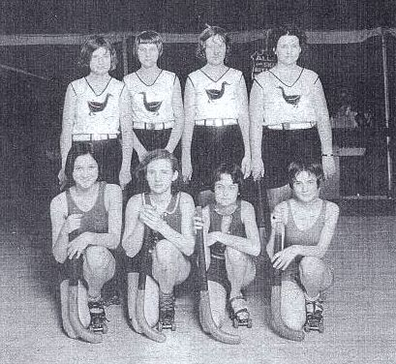

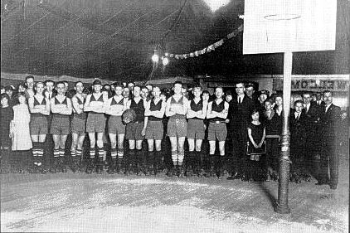

Whether it was time to settle down in one place, or the changes of World War II and the scarcity of canvas, or the boom that was taking place in roller skating, the Lowe family landed in Birmingham, Alabama, in the early 1940s and opened a traditional indoor facility. Though portable tent rinks would survive for a few years after the war, the golden age of the traveling rolling show was over. But a reincarnation of that experience has been reborn. No longer under canvas tarp, what is known as pop-up rinks have appeared across the country. More likely in an urban setting than rural, they provided the temporary enjoyment of roller skating when a permanent facility is not always available, hawking back to a time when the Lowe’s set up a temporary shop to provide joy and fun to communities.

The pictures below are from Lowe's permanent indoor rink, in Birmingham Alabama, beginning in the early 1940s.

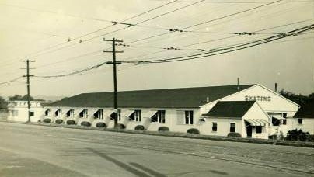

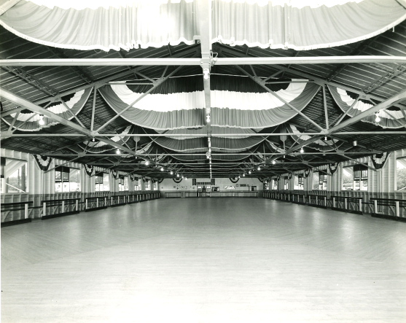

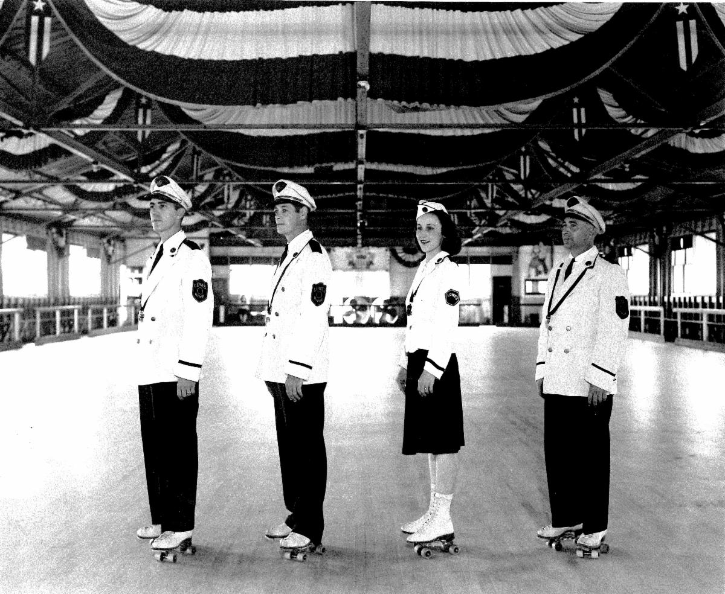

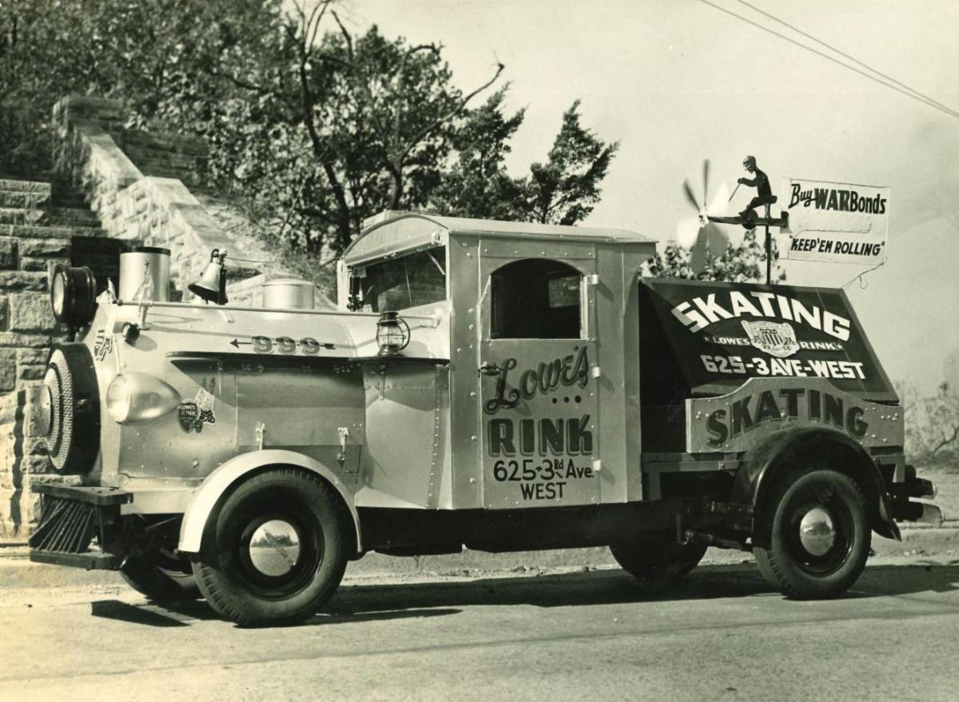

STAY CONNECTED

The National Museum of Roller Skating | (402) 483-1465 extension 203
director@rollerskatingmuseum.com
4730 South Street, Lincoln, NE 68506
www.rollerskatingmuseum.com



The National Museum of Roller Skating is a 501(c)3 non-profit organization located in Lincoln, Nebraska. It is the only dedicated roller skating museum in the world. We are committed to the preservation of the history of roller skating. With over 50 displays cases, the museum educates the public on all aspects of roller skating, which dates back to the first patented skate from 1819.

Copyright: Rolling Thru Time is published throughout the year by the National Museum of Roller Skating.
Copyright 2018 by the NMRS. Written permission from the museum is required for reproduction of any part of this publication.
Rolling Thru Time welcomes stories, art and photo contributions. These works selected for publication may be edited to conform to size and other requirements. Opinions expressed by the authors are not necessarily those of the museum. Correspondence concerning articles is welcomed. Statement of fact and opinion are the responsibility of the authors alone.

﻿Officers and Trustees:
President: Kim Wall; Vice President: Nellie Anderson Lillie; Treasurer: Alan Bacon; Secretary: Peggy Young.
Other Trustees: Annelle Anderson, past president, Alexis Cruz, Danny Brown, Dominic Cangelosi, Charlene Conway, Rob Gould, Bill Hoefler, Ed Hughes, Michael Jacques, Judith Young Link, Jim Link, Linda Miner, Jeanne Sincavage, Andy Starr, Billy Thompson, Cort Wahlig, and Tina Robertson Winkler.
Trustees Emeritii: Bob Bollinger, Michael Brooslin, James Turner, Scott Wilhite and Mike Zaidman.
Writer/Editor of Newsletter: Alan Bacon; Copy Editor: Joy Bacon; Graphic Designer: Kelsey Bacon.

