April 2022

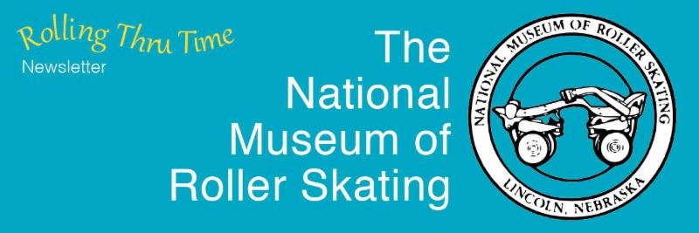

Visit our Website



Raffle and Lincoln Day
﻿Fundraisers Approaching
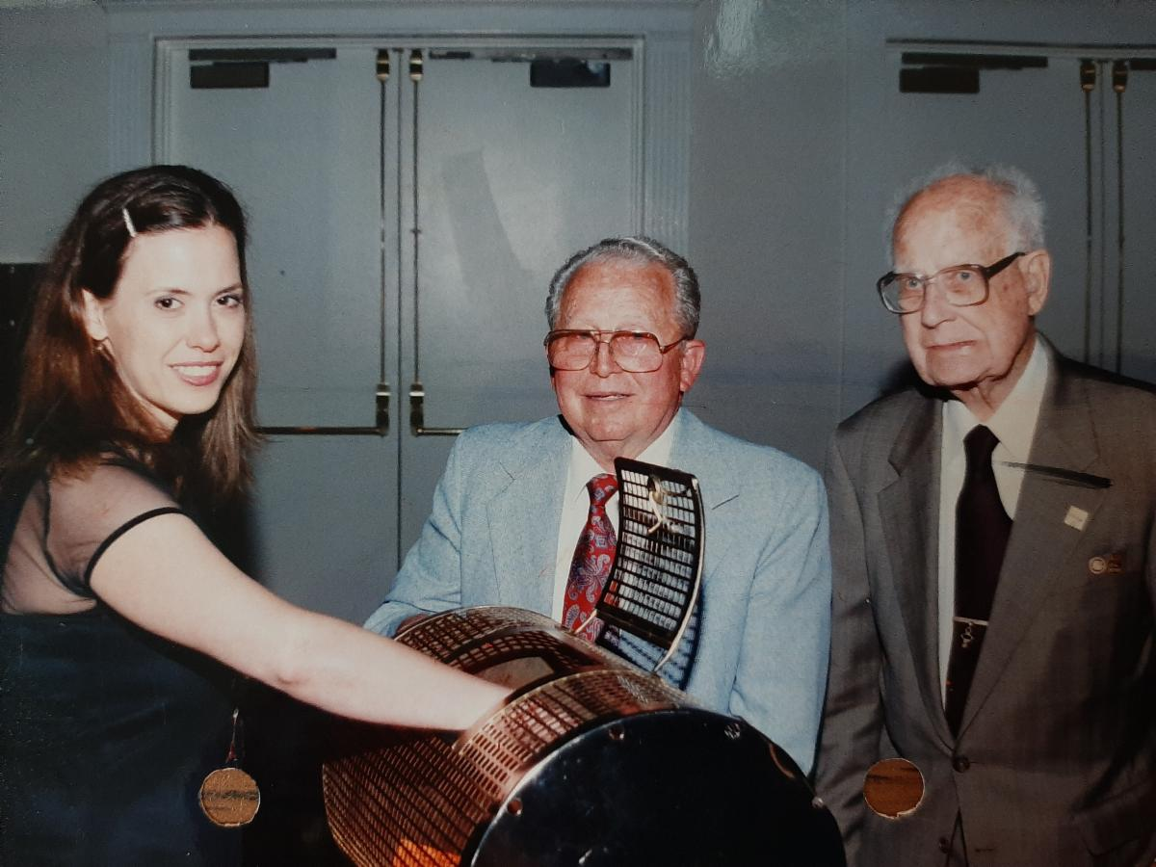

Raffle ticket drawing from the RSA Convention in San Diego in 1999.

﻿“Mills Lynn (center) and Robert Bollinger (right) were incredibly motivated and energetic when it came to selling raffle tickets and always emphasized how important the raffle is for the Museum,” said Nellie Anderson Lillie (left), current museum vice president. They always made selling raffle tickets a lot of fun and I had to really work hard to keep up with them . . . but I tried!”
The two most important yearly fundraisers for the Museum are fast approaching. The annual raffle at the RSA National Convention will be from May 2-4. Raffle tickets can be purchased at the convention. If not attending, then one can contact a RSA sectional director or any Museum trustee for purchase. You can also contact the Museum by April 30 to purchase a ticket 402.483.7551 Ex 1203.

In addition to the raffle, one can donate to the annual Lincoln Day Fundraiser put on by The Lincoln Community Foundation. Your donation is supplemented by the Foundation based on the amount of financial support each organization receives from its supporters. This is the most beneficial way that a person can donate to the Museum. Not only does the entire donation goes to the Museum, but money is added by the Foundation. And with a donation of $35 or more, a one-year individual Museum membership is granted. Donations are accepted between May 1 and May 26.

Go to www.givetolincoln.com and follow the prompts and type “National Museum of Roller Skating” in the “Find a nonprofit” search bar. The Foundation prefers online donations. They state that there is no advantage to a donor to giving with a check instead of their credit/debit card because the same processing fee applies. Online donations are visible to each nonprofit in real-time, and the donor receives an instant tax receipt. If you prefer to send a check, address it to Lincoln Community Foundation, and put the National Museum of Roller Skating in the memo line. It must be postmarked by May 23 to Lincoln Community Foundation, 215 Centennial Mall S, Lincoln, NE 68508

If you donate to this fundraiser, but would like to give more detail to the Museum on the purpose of the donation whether it is for membership or in memorial, for example, please email Peggy Young at the Museum. pyoung@rollerskatingmuseum.org.

Innovative Fundraiser - Axe Throwing!

“Despite rain, freezing rain, sleet and snow, we managed to raise $600 for the museum,” said Ed Hughes, museum trustee. He led the efforts for the Section 4 fundraiser for the Museum at its recent meeting. This follows other recent fundraisers by rink owners Brad Armstrong and Billy Thompson in behalf of the Museum.

“It was really pretty simple,” said Hughes. “I wanted to host a social activity on Sunday night before the section meeting on Monday. Since convention attendees last year had so much fun doing it, I thought why not us. Through sponsorships, I was able to pay for the three lanes that we rented and then charge all the attendees $20 which all went to the museum. It turned out to be a great little social affair.”

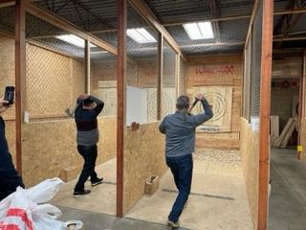

Museum Highlights

Museum Receives Grants for Oral Interviews

A $10,000 grant to do a long- desired oral history project was spearheaded by Alexis Cruz, Museum archivist, and Peggy Young, museum secretary. The grant from Humanities Nebraska will fund Amy Richardson, former Museum archivist, to do numerous interviews, mostly by zoom or phone. The grant money must be spent by November, but the project can be extended by making a donation to the Museum. Be sure to indicate by email or phone that the funds are to be earmarked for this project. Kim Wall, museum president, has already donated to this project. Caroline Mirelli, former Skating Vanities star, long-time coach, and former rink operator, was the first to be interviewed.

Richardson, who is conducting the interviews, has a Master’s in Folklore, a discipline whose fundamental skillset includes conducting ethical interviews. She interviewed many people throughout graduate school for classes and for her master’s thesis. She did a two-week intensive field school, where she went to a small town in Newfoundland, learned how to interview, interviewed locals, and created a presentation on said interviews. For her thesis, she had to pass an ethics review, and received a deep understanding of how to keep an interview ethical and safe for people being interviewed.

“I try to find a happy balance between staying completely silent as an interviewer and making small responses to show the interviewee that I am engaged,” said Richardson. “It’s certainly an art form over the phone, as they aren’t able to read your body language, so it is more difficult to remain completely silent as I’d like to do,”

An additional grant for security cameras to help staff monitor who is entering and exiting the building was provided by the Lincoln Community Foundation, also spearheaded by Cruz and Young. This grant included the purchase of a sign for the parking lot that can be used to direct handicapped guests to the handicapped entrance.

New Museum Audio Tour

A new audio tour of the Museum using QR codes has been developed. Guests can listen to information on 15 displays in the main exhibit area. Changes and updates can easily be made to the system. To listen to them, go HERE.

Staff Changes

The Museum has had some personnel changes. The new archivist is Max McKillip. He majored in history at the University of Nebraska. Alexis Cruz, former archivist will be helping with the transition, including help with grants for a limited time. Nora Fitzgibbon will be interning at the Museum. She has a Bachelor of Arts Degree from the University of Nebraska. She will handling the Museum’s social media accounts, adding to the Museum’s cataloged acquisition program, and doing research. Cruz set up a working relationship with the college and they have the Museum on a list that they would like to send interns to for college credit.

Museum Hours Changing

The Museum will soon be open on Saturdays from 10 am – 3 pm. In addition, the Museum will be open Wednesday thru Friday also.

Museum Donations

S.H. Engle. Donation for Contract Employee Salary
Tina Robertson Winkler for Printing the Raffle Tickets for the Annual Raffle.

Peggy Young Memorial Bud Engle
Bob and Annelle Anderson Memorial Judy Robertson
Bob and Annelle Anderson Plaque Bud Engle
Donna & Michael Drusbacky Memorial Bud Engle
Peggy Bauman & Susan Dole. Memorial Bud Engle
Bob and Annelle Anderson Memorial Richard Koonce
South Central USARS Region Memorial Richard Koonce
Caroline Mirelli Memorial Bud Engle
Bob & Annelle Anderson Memorial Pat Hanaway
Caroline Mirelli Memorial Pat Hanaway
Johanna Barage Memorial Bud Paton
Harry Walker Donation
Caroline Jewett In Memory to a Dear Friend Janina Bacich
John Kenny Donation Regarding Sister’s Scrapbook

If memorial donations are made through the website, please send an email to Peggy Young pyoung@rollerskatingmuseum.org to identify who it is for and provide an address where notification to the family should be sent of the donation.

Museum Annual Board Meeting

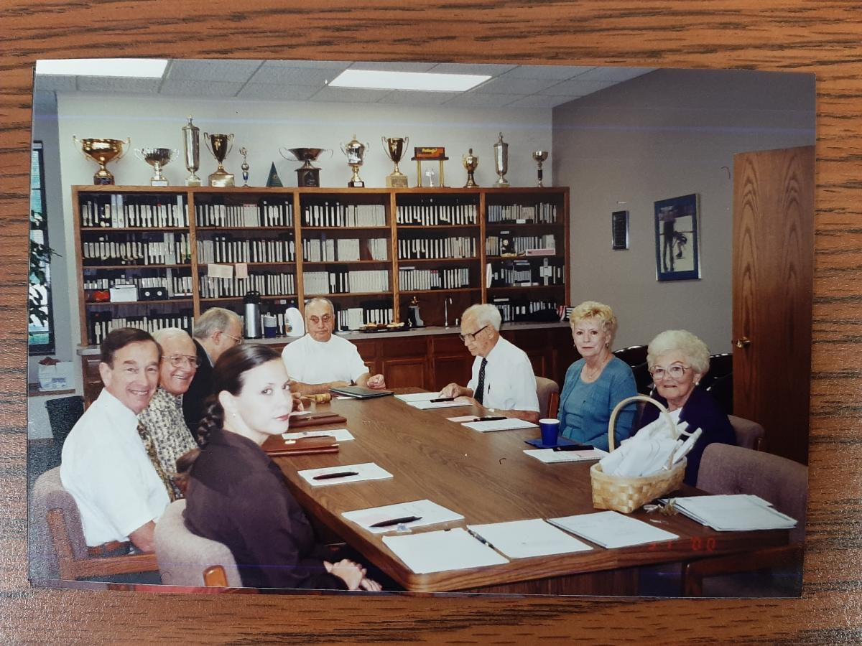

The photo of the Museum’s board meeting is believed to be from the late 1990s. It might have been Bert Anselmi’s (end of table) last meeting as Museum president,” said Nellie Anderson Lillie, current Museum vice president. “Bert is very likely the top reason why I became involved with the Museum. In my very early 20s he had many long talks with me on why we always need to work for the Museum. His leadership was brilliant and humble. Incredible leader and person.”
﻿
Pictured from left to right: Nellie Anderson Lillie; Chester Fried, vice president; Frank Cernick; George Pickard, secretary/treasurer; Bert Anselmi, president; Robert Bollinger, Annelle Anderson; and Charlotte Groves.

The annual Museum board meeting is scheduled for Sunday, May 1 at the DoubleTree Hilton next to Universal Studios in Orlando, Florida. The meeting will start at 2:00 pm Eastern Daylight Time, in Gold Coast Rooms 1 & 2. The board meeting will be held both in-person and by Zoom. This meeting is taking place during the RSA national convention.

Photo Feature: Museum Trip
By Alan Bacon

Last spring I had the opportunity to travel to the Museum and spend a week doing research in the archives. It was like a child having access to a candy store. The Museum visible to most people is only a portion of what the Museum contains. In the many boxes of photos, there was one with historic photos of the Museum itself, and some of the people that have worked to maintain it over the years. Besides the two already shown above, below are some others.

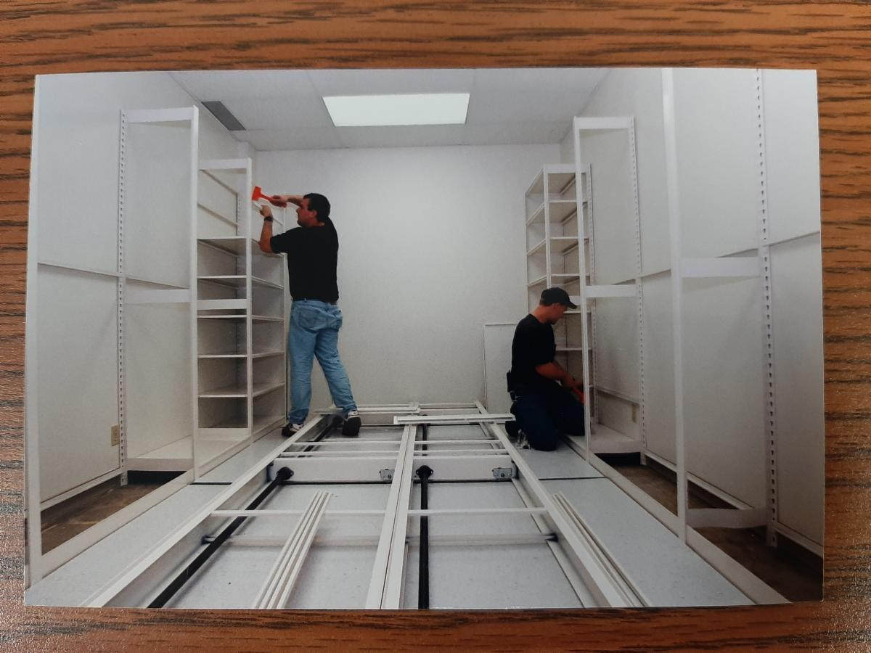

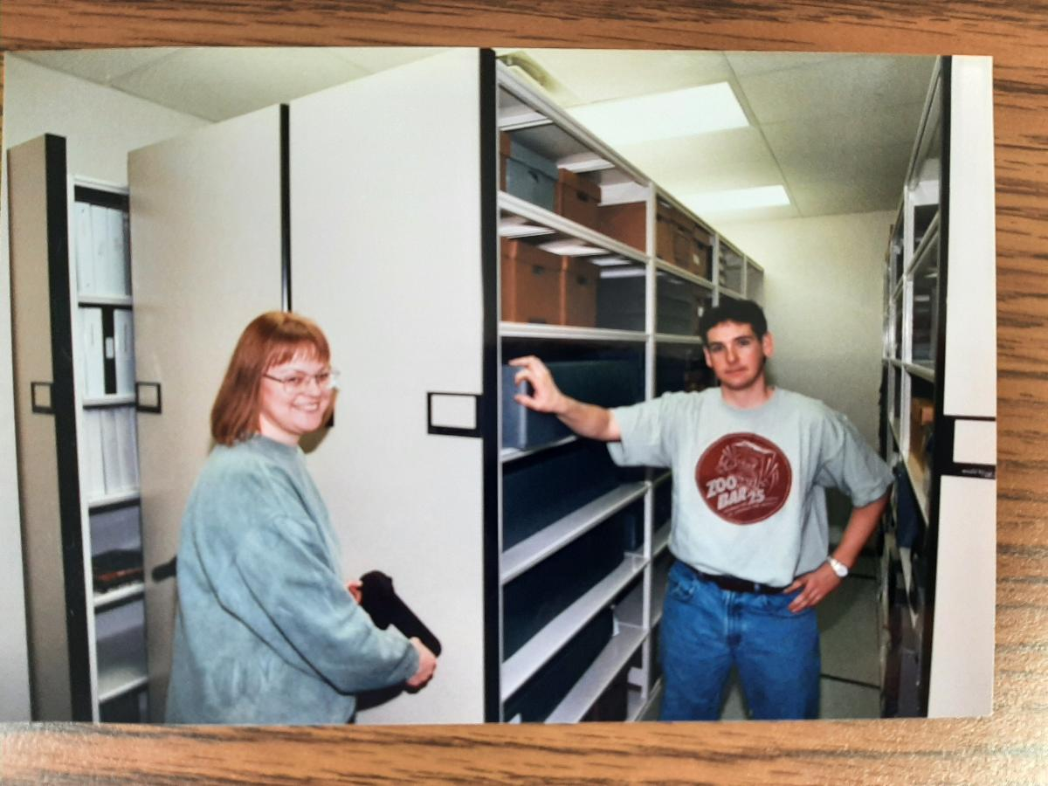

These two photos above date to 1999 when the new SpaceSaver shelving system was installed. This project was made possible by the largest grant the Museum had received up to that time, $8,686. This storage system increased storage in this room by 158 percent. The original storage shelves in the archives were badly bowed and a hug amount of space in the middle of the room was virtually unusable as storage space. Picture from left to right is Susan Curtis, assistant curator, and Michael Zaidman, Museum director and curator.

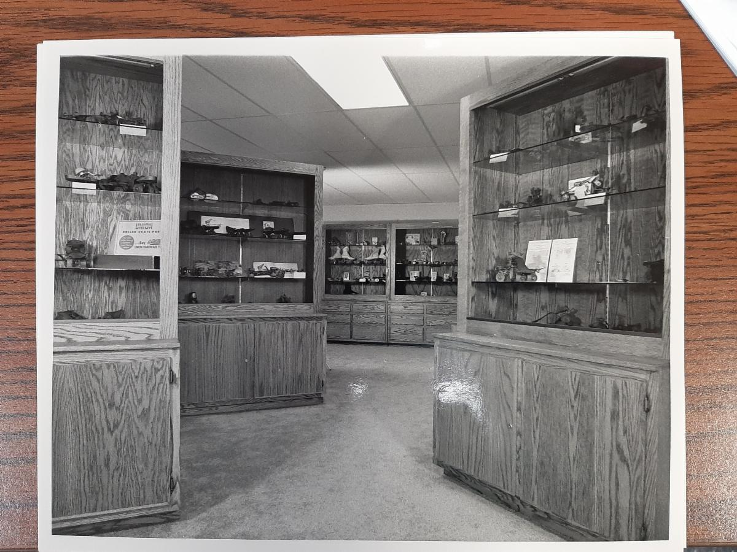

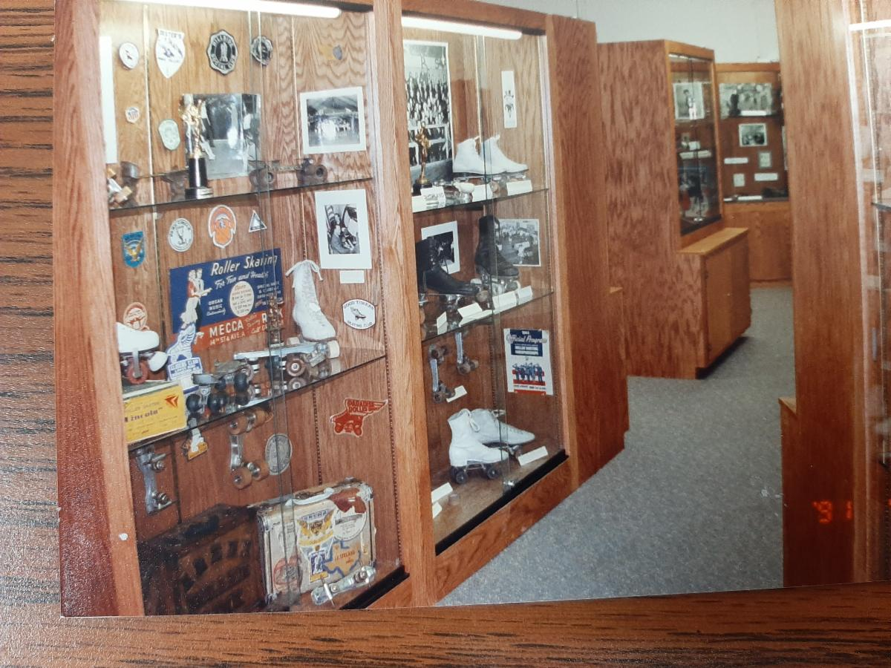

The second two photos of the Museum are not dated but most likely are from the 1980s or 1990s.

The two photos below of the Museum were taken in the Spring of 2021.

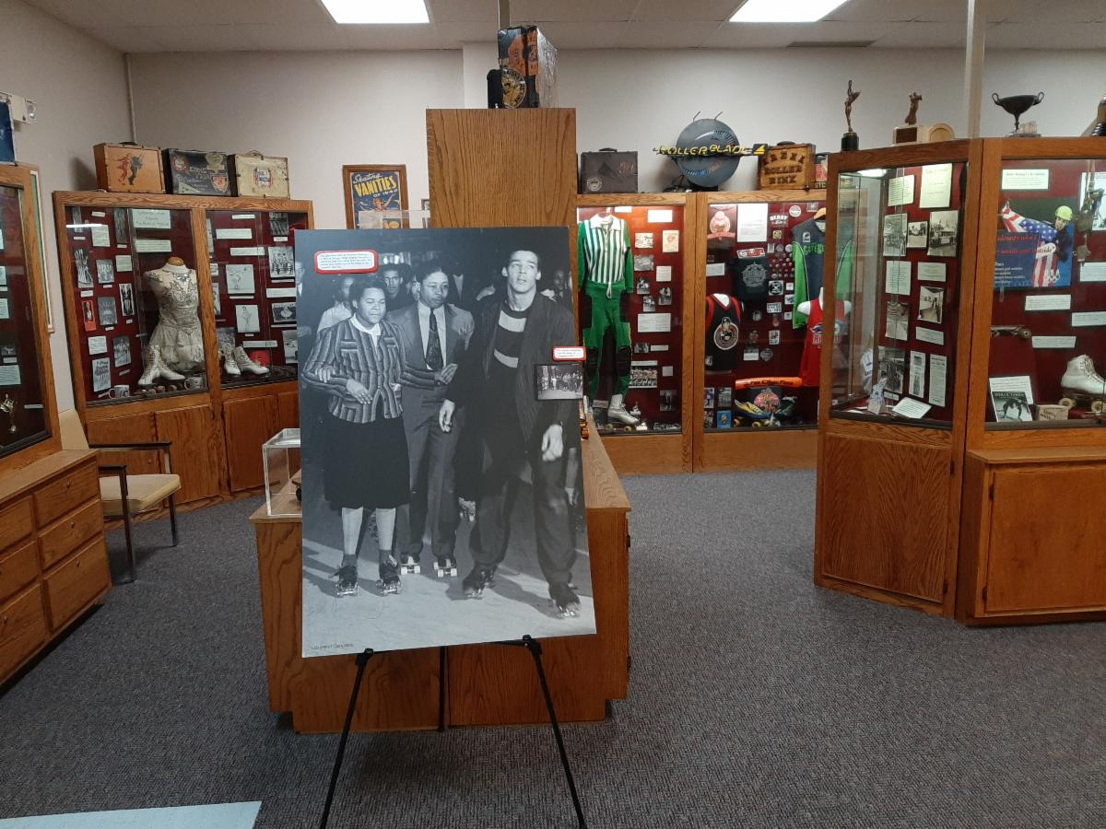

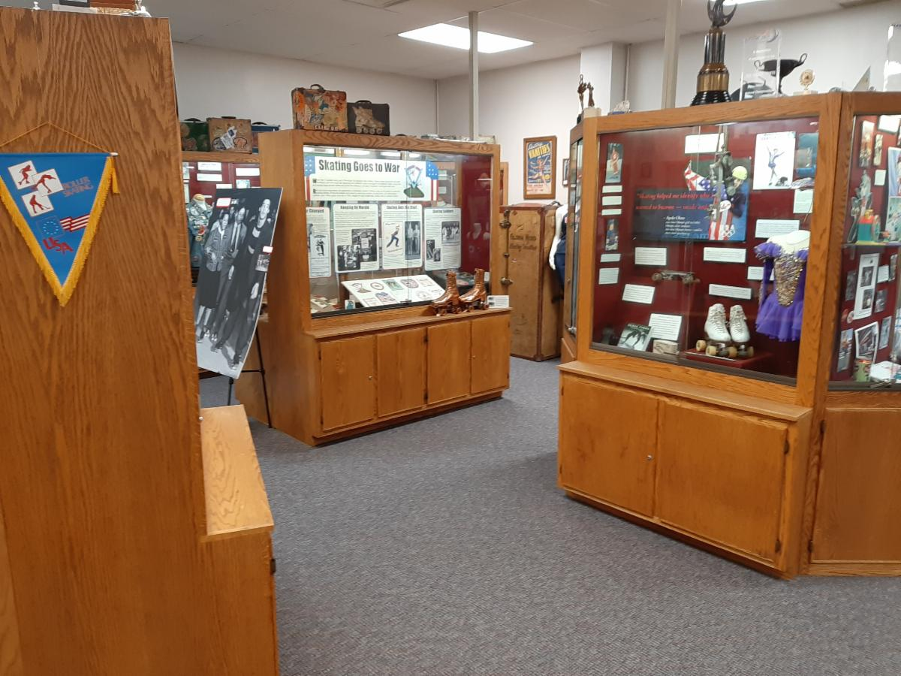

The last, very historic Museum photo, was taken in 1982 when the Museum opened.

﻿Pictured are the original Museum trustees. From left to right: George Pickard, Bert Anselmi, Dick Young, Mike Brooslin, Marvin Facher, Robert Bollinger, James Turner, and Chester Fried.

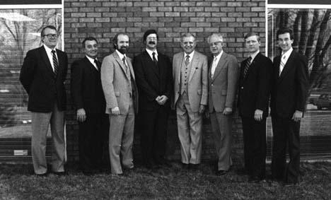

STAY CONNECTED
The National Museum of Roller Skating | (402) 483-1465 extension 203
director@rollerskatingmuseum.com
4730 South Street, Lincoln, NE 68506
www.rollerskatingmuseum.com

‌ ‌ ‌

The National Museum of Roller Skating is a 501(c)3 non-profit organization located in Lincoln, Nebraska. It is the only dedicated roller skating museum in the world. We are committed to the preservation of the history of roller skating. With over 50 displays cases, the museum educates the public on all aspects of roller skating, which dates back to the first patented skate from 1819.

Copyright: Rolling Thru Time is published throughout the year by the National Museum of Roller Skating.
Copyright 2018 by the NMRS. Written permission from the museum is required for reproduction of any part of this publication.
Rolling Thru Time welcomes stories, art and photo contributions. These works selected for publication may be edited to conform to size and other requirements. Opinions expressed by the authors are not necessarily those of the museum. Correspondence concerning articles is welcomed. Statement of fact and opinion are the responsibility of the authors alone.

﻿Officers and Trustees:
President: Kim Wall; Vice President: Nellie Anderson Lillie; Treasurer: Alan Bacon; Secretary: Peggy Young.
Other Trustees: Annelle Anderson, past president, Danny Brown, Dominic Cangelosi, Charlene Conway, Bill Hoefler, Ed Hughes, Michael Jacques, Judith Young Link, Jim Link, Linda Miner, Randy Ray, Jeanne Sincavage, Andy Starr, and Tina Robertson Winkler.
Trustees Emeritii: Bob Bollinger, Michael Brooslin, James Turner, Scott Wilhite and Mike Zaidman.
Writer/Editor of Newsletter: Alan Bacon; Copy Editor: Joy Bacon; Graphic Designer: Kelsey Bacon.

